**PCO2 control**

1. **on-off method**

−    Subsequent triggering of the ERV would be dependent on CO2 level monitored within the room. In the event the CO2 level exceeds the pre-set level, the ERV would be turned on.

−    The pre-set level of CO2 is 900ppm. The ERV will start to work when the real time records exceed 800ppm.

−    The ERV continues to run till the CO2 level within the room drops below the pre-set level.

−    The lower limit of the CO2 level is 600ppm. The ERV will stop working when the real time records drop below 600ppm. (the outdoor CO2 level is close to 410ppm)

−    When  the  ERV  is  in  operation,  its  fan speed is  regulated  to  achieve  positive pressure in the room.

1. **PID based method**

Pid controller will automatically manipulate ERV supply air fan speed to keep the room CO2 concentration set-point. The set point will be in the range from 600 to 900 ppm.

Once the CO2 is above 900, turn on the supply air fan with maximum speed; once below 600ppm, turn off the supply air fan.

During the system commissioning, the PID parameters should be appropriately tuned. Commonly we use a conservative PI control and set the parameters Kp and Ki.

The sampling time for PID control should be somewhat big, for example 1 min to 3 minutes.

1. **CO2 change rate based method**

**When the CO2 concentration exceed 900ppm, turn on the ERV; When CO2 concentration drop below 600ppm, turn off the ERV.**

**The fan speed is control by the CO2 concentration change rate.**

Human being generate 37.5g CO2 per hour.



Assume the occupied zone with area of 100m2. ceiling height 3m。 Then volume 300m3.

If the CO2 concentration indoor is 800ppm. Then it equals to 1.571g/m3

The outdoor CO2 concentration is 400ppm which equals to 0.786g/m3

Assume x people in the zone. The fresh air required to maintain 800pm:

CO2 generate=37.5x g/h

Fresh air flow= 37.5/(1.571-0.786)=47.8x m3/h

The x can also be converted to change rate which is related to zone dimension, sampling frequency (N=times/hour).

Change in ppm per hour

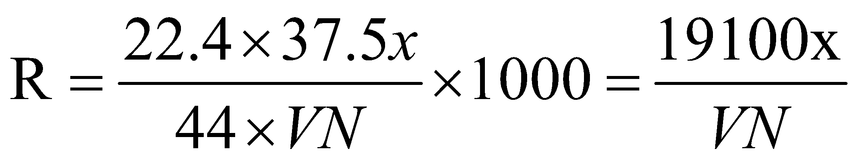

Then fresh air flow:

